3. NON-TRADITIONAL MACHINING
MACHINING: It’s a process of removal of unwanted material form the surface of workpiece in the form if chips by the application of force from hard tool.
Conventional Machining: 1) Tool must be harder than workpiece, 2) Tool should be always in contact with workpiece.
TYPES OF MATERIAL REMOVAL PROCESS
Conventional Machining |  |  |  | Abrasive processes |  | Non-Traditional Machining
Turning and related operations | Drilling and related operations | Milling | Other Machining operations | Grinding Operation | Other Abrasive processes | Mechanical Energy process | Electrochemical machining | Thermal energy processes | Chemical Machining
LIMITATIONS OF CONVENTIONAL MACHINING:
- New materials having high strength & hardness, improved thermal & mechanical properties such as Nimonic Alloys and alloys with alloying elements such as Tungsten, Molybdenum are difficult to machine by the traditional method.
- Conventional machining can’t meet the new and usual machining requirements of Aerospace and Electronics industries, they are either not possible or very costly.
- Tool must be at least 30-50% Harder than workpiece.
- Extremely brittle materials like Glass can’t be machined.
- Extremely Soft Materials like Rubber is not possible to machine.
- Complex shapes of components e.g. Spherical, Concave, Convex, Contour shapes are very difficult to machine.
- Very Fragile and delicate materials and objects can’t be clamped during machining.
- Very small diameter of hole e.g. 0.1 mm is not possible to machine.
- Small dimension non-Circular holes e.g. Square, rectangular, Triangular, hexagonal are not possible to manufacture.
- Zig-Zag holes can’t be machined.
- Excellent surface finish & dimensional accuracies can’t be achieved.
NON-TRADITIONAL MACHINING:
- When tool need not required to be harder than workpiece and tool is not required to be in physical contact with workpiece, such a machining operation are called as non-traditional machining process.
- Here, Different forms of energy directly applied to the workpiece to have shape transformation or material removal from work surface.
- Types of energies are applied are mechanical, thermal and chemical for removal of material from the surface of the workpiece.
CLASSIFICATION OF NTM:
Classification according to the major energy source employed during machining
Mechanical | Thermal | Chemical & Electrochemical
Ultrasonic Machining (USM)  Water jet machining (WJM)  Abrasive Water jet machining (AWJM)  IJM | Electric Discharge (EDM)  Electron Beam (EBM)  Laser Beam (LBM)  Iron beam (IBM)  Plasma beam (PBM) | CHM  PCM  Electro chemical (ECM)
$$Wear Ratio={Volume of material removal form workpiece}/{Tool Wear}$$
TOP 10 FEATURES FOR EXAM: 1) Mechanism/ Principle of Machining, 2) Workpiece Material, 3) Tool Material (Properties), 4) Medium of Machining, 5) Wear Ration, 6) Advantages, 7) Limitations, 8) Applications, 9) MRR, 10) Influencing factors on MRR.
ULTRASONIC MACHINING:
Sr. No. | Features | Description
1 | Mechanism/ Principle of Machining | Brittle fracture. Piezoelectricity effects Quartz in the piezoelectric transducer. Transducer Vibrates tools with (f = 20-30 KHz, A= 10-100 μm) and controlled by servo system. And KE gain by Slurry and hits Workpiece. So, brittle fracture takes place.
2 | W M | Hard and brittle metallic alloys, Semiconductors, Glass, Ceramics, Carbide.
3 | T M | Soft and Ductile E.g. Aluminium and copper
4 | Medium of Machining | Abrasive Slurry (Al2O3/ SiC/ B4C/ Diamond dust + Water/ paraffin). It’s pumped in between Inter electrode gap. And recirculation of Slurry is important. IEG is maintained by servo mechanism.
5 | Wear Ration | Neither infinite not zero (10-100)
6 | Advantages | - Workpiece need not required to be electric conductor.  - It’s non-hazardous process.  - Hard materials can be machined. |  | - As there is no heat generated during machining, there is no hardening of workpiece/ No heat affected zone.
7 | Limitations | - Low MRR.  - High tool wear.  - Low depth of hole.  - Soft or Ductile materials cannot get machined. |  |  | - Surface finish is 0.5 to 0.7 μm.  - Generally, hole tolerance/ Accuracy is 25 μm.
8 | Applications | - It’s used in machining hard and brittle metallic alloys, semiconductors, glass, carbide and advance ceramics for application in auto engine components.  - In machining of small dies for wire drawing, punching and blanking.  - Drilling small holes in borosilicate glasses for sensors used in electronic industries.  - It’s used for generating painless holes in human teeth.  - Used for generating non-Circular holes.
9 | MRR | Remains Constant.
10 | Influencing factors on MRR | $$MRR∝Hardness of Workpiece$$  $$MRR∝Frequency of Vibration$$  $$MRR∝Amplitude of Vibration$$  $$MRR∝Mean Grain Diameter$$  $$MRR∝\% of abrasive particles$$  $$MRR∝Feed Force$$  $$MRR∝{\left(Viscosity\right)}^{-1}$$ | Up to optimum grain size MRR increases and then decreases.  40% to 60% of abrasive particles in the slurry are optimum/ maximum MRR.  MRR increases with Feed Force but suddenly decreases after some value due to failure of particles.  MRR drastically decreases with increase in viscosity.

USM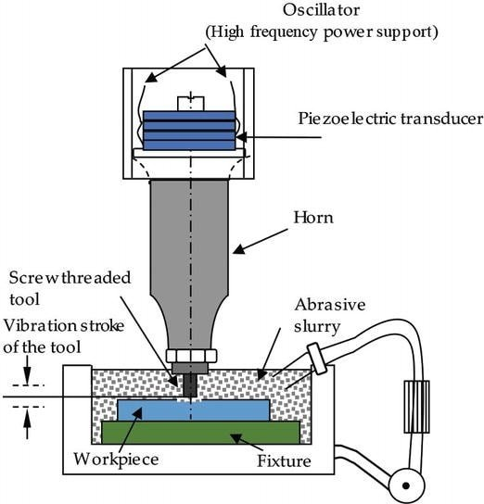 | EDM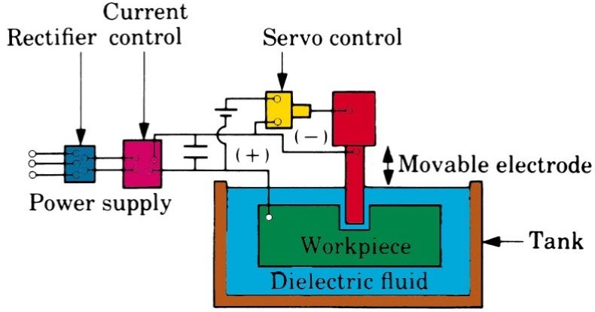
ELECTRIC DISCHARGE MACHINING (EDM):
Electrode is connected (-ve) or cathode and Workpiece is connected to (+ve) or anode. Inter Electrode gap is maintained throughout the process. All process is carried out in the dielectric medium e.g. Kerosene. The RC Relaxation Circuit is used in the process. Voltage is of the electrode becomes so high that medium breakdown (Ionization) takes place and spark is generated. Out of total cycle time charging time is around 75 -85% of the cycle time and discharge time is around 15-25% of the cycle time. Hence, machine remains idle during 75-85% of time. During spark, electrons moves with very high velocity towards the surface the workpiece. Due to this high velocity of striking on the surface of workpiece (Temp. becomes around 10K 12K $°$C), melting and vaporising of the material takes place. The Die electric material Circulation pump (+Filter) is installed and which takes out the melted and vaporized parties (Solid Debris) near to the vicinity of the surface.
Spark: It’s life line is small. | Arc: When Spark remains for longer duration it’s called Arc.

Properties:
Tool | - Melting point should be high.  - Good thermal conductor of heat and electricity to reduce wear. | - Specific heat should be high.
Tungsten is bad conductor of heat. Hence, alloy of tungsten is used as tool.
Sr. No. | Features | Description
1 | Mechanism/ Principle of Machining | Melting and Vaporizing.
2 | W M | Material should be electric conductor
3 | T M | Graphite, Copper Graphite, Copper Tungsten alloy or Silver Tungsten
4 | Medium of Machining | Die electric medium E.g. Kerosene
5 | Wear Ration | $≠$ Infinite (Tool wear $≠$ 0)
6 | Advantages | - Quality of Surface produce is good.  - As there are no force involved, therefore there will be no residual stresses.  - The process is not affected by the hardness of the work material. Hence, even hardened materials can be machined.  - High reactive materials like Aluminium & magnesium can be machined.  - MRR is higher E.g. MRR is almost comparable with conventional machining process.  - Any complex shapes required in dies and moulds can be easily produced to the required degree of accuracy and finish. Since the process copies the cool shape in a complementary form.
7 | Limitations | - The Workpiece should be electrically conductive to be machined using EDM process.  - The wear rate or electrode is considerably higher. Sometimes it may necessary to use more than one electrode to finish the job.  - The energy required for the machining operation is higher than conventional machining process and hence, will be more expensive.  - Hardening takes place Surrounding to the hole.  - Hear Affected Zone is very large.  - Tapering (Taper cut) or Overcut of the hole takes place.
8 | Applications | - EDM is used for making fragile parts which can’t take stress of machining.  - It’s used for machining of exotic materials that are used in aerospace and automotive industries. (Exotic Materials can include plastics, superalloys, semiconductors, superconductors, and ceramics.)  - EDM is used for making dies for wire drawing, extrusion, forging etc. from harden steel and stamping tools with intricate cavities.  - Deep Cavities, Slots and Ribs can be made.  - Micro EDM process can successfully produce micro-pins, micro-nozzles and micro-cavity.
Formulas:
$$t=t_{c}+t_{d}$$  $$V=V_{S}\left(1-e^{-\frac{t}{RC}}\right), hence V_{d}=V_{S}\left(1-e^{-\frac{t_{c}}{RC}}\right)$$  $$Energy Released per spark =\left(1/2\right)CV_{d}^{2}$$  By ignoring discharge time, $t=t_{c}$  $$t=RC\ln\left[\frac{V_{S} }{V_{S}-V_{d} }\right]$$  $$Average power Input =\frac{Energy Released per spark }{Cycle Time}$$  Frequency of the charging (f) $=1/t$ | t = Cycle Time.  $t_{c}$ = Charging Time.  $t_{d}$ = Discharge Time.  $V_{S} or V_{a}$ = Supplied or applied voltage.  $V_{d}$ = Discharge Voltage.  V = Voltage at any given time.
WIRE CUT EDM:
All things are similar to EDM. Here, tool is in the form of wire. Wire is feed as well as re-circulate. And once usage/ Re-Circulation of wire it’s not usable for second time because of degradation of quality of wire.
- Spark Gap (S) is the distance which is required to take place spark. Hence, extra material removed than the wire diameter ($d_{w}$) due to spark gaps.
- Kerf is the width of cut. Hence, $Kerf=2S+d_{w}$
- $MRR =Kerf*Thickness of material*Feed Velocity$
APPLICATIONS OF WIRE CUT EDM:  - Aerospace, medical, electronics and semiconductor applications  - Tool & Die making industries.  - For cutting the hard Extrusion Dies.  - In making Fixture, Gauges & Cams.  - Cutting Gears, Strippers, Punching & Dies.  - Manufacturing of hard Electrodes.  - Manufacturing of Micro-tooling for Micro-EDM, Micro-USM and such other micro-machining applications. | WIRE CUT EDM 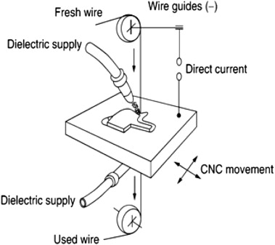
ELECTRO CHEMICAL MACHINING (ECM):
Electro-Platting or Electro-Coating: Anode (+ve) (Platting Material) and Cathode(-ve) (Object) is emerge in electrolytic solution. And electricity is passed through the system. The Anode is reduces/ Depleting the material in the form of the ions and this ion travels toward cathode through the electrolytic solution and the Anode material deposits on the cathodes. This process is called Electro-Platting or Electro-Coating.
ECM: Anode (+ve) (Workpiece (Fe)) and Cathode(-ve) (Tool (Fe)) is emerge in electrolytic solution (NaCl+ Water). In the Same way of electro-platting the Ion delating or ion dissolution is happens here. So as to avoid the deposition of Anode material on the Workpiece we are pumping out the Electrolytic the solution continuously. Here,
Give Electric charge | $$NaCl→{Na}^{+}+{Cl}^{-}$$ | $$Fe→{Fe}^{++}+2e^{-}$$ | $$2H_{2}O→2{\left(OH\right)}^{-}+H_{2}↑$$
Precipitate | $${Fe}^{++}+2{\left(OH\right)}^{-}→Fe{\left(OH\right)}_{2}$$ | $${Fe}^{++}+2{\left(Cl\right)}^{-}→Fe{\left(Cl\right)}_{2}$$ | $${Na}^{+}+{\left(OH\right)}^{-}→Na\left(OH\right)$$

Sr. No. | Features | Description
1 | Mechanism/ Principle of Machining | Ion Dissolution/ Ion Depleting
2 | W M | Good conductor of electricity
3 | T M | Any Good conductor of electricity (Generally same as Workpiece)
4 | Medium of Machining | Conducting Electrolyte
5 | Wear Ration | = Infinite (Tool wear = 0)
6 | Advantages | - Complex three-dimensional components or surfaces can be machined accurately.  - Since there are no cutter marks, surface finish will be excellent.  - MRR is independent of mechanical properties of workpiece, E.g. Hard materials can be machined easily.  - As there is no heat generated during machining, therefore there is no hardening of workpiece.  - Tool Wear is Zero, which results in a large number of components per tool.
7 | Limitations | - Very expensive machine.  - Sharp interior edges and corners are difficult to produce. (Tapering (Taper cut) or Overcut of the hole takes place)  - Use of corrosive media as electrolyte makes it difficult to handle.  - The workpiece should be electrically conductive to be machined using ECM.
8 | Applications | - ECM can machine any electrically conductive work material irrespective of their hardness, strength or even thermal properties.  - Moreover, as ECM leads to atomic level dissolution, the surface finish is excellent with almost stress-free machined surface without any thermal damage so fragile and thin section can be machined.  - ECM is used for: Die Sinking, Profiling and Contouring, Trepanning, Grinding, Drilling, Micro Machining etc.
10 | Influencing factors on MRR | - FARADAYS FIRST LAW OF ELECTROLYSIS: This law states that “The mass of a substance deposited or liberated at any electrode is directly proportional to the amount of charge passed”  $$Material Removed ∝Q, hence MRR ∝I$$  - FARADAYS SECOND LAW OF ELECTROLYSIS: This law states that “The mass of a substance deposited or liberated at any electrode on passing a certain amount of charge is directly proportional to it’s chemical equivalent weight” $MRR∝e,where$  $$Electro Chemical equivalent of W.P.=e={Atomic Weith}/{Valence}$$  $$MRR∝\frac{A I}{Z F}$$ A = Gram Atomic Weight (Gm), I = Supplied Current (Amperes), Z = Valency, F = Faradays Constant = 96, 540 C  - $MRR∝{\left(Distance between the electrods\right)}^{-1}$  - $MRR∝Conductivity of conducting Electrolytic Solution$  - $Surface Roughness \left(μAARH\right)∝\left(MRR\right)∝Electrolyte Conductivity$  Passivating Electrolyte: Electrolyte Conductivity is very high
MRR SEQUENCE: ECM > EDM > USM > EBM > LBM
VALENCY: The combining capacity of an atom is called valency. Thus, it is the number of valence electron an atom has to gain or lose from it’s outer orbit. $Valency of n^{th} orbit=2 n^{2}$.
GRAM ATOMIC WEIGHT: It’s amount of atomic substance whose weight (in grams) is numerically equal to the atomic weight of that substance.
FORMULA:
- Mass MRR (gm/s) = ${A I}/{ Z F}$ |  | Volumetric MRR (mm³) = ${Mass MRR}/{Material Density}$
- For Alloy A B (x%) (1-x%)
$$Mass=\frac{I e}{F}$$ | $$Volumetric=\frac{I}{F\left(\frac{ρ_{1}Z_{1}}{A_{1}}\frac{x}{100}+\frac{ρ_{2}Z_{2}}{A_{2}}\frac{(1-x)}{100}\right)}=\frac{I e}{Fρ_{AB}}$$ |  |  | $$\frac{1}{e}=\left(\frac{Z_{1}}{A_{1}}\frac{x}{100}+\frac{Z_{2}}{A_{2}}\frac{(1-x)}{100}\right)$$
- V = IR  $V_{O}$ will never utilised in the system but it’s applied. Hence, $V = V_{S}-V_{O}=IR$  $$R={ρl_{gap}}/{Cross Section Area of tool}$$  $$Conductivity={\left(Resistivity\right)}^{-1}$$ |  |  | R = Resistance between electrode gap,  I = Current supplied,  $V_{S} or V_{a}$ = Supplied or applied voltage,  $V_{O}$ = Supplied Over Potential voltage,  $ρ$ = Specific Resistivity,
- Volumetric MRR = $V_{f}$ * Cross Section Area of tool  $$V_{f}=\frac{{A I}/{ ρ Z F}}{Cross Section Area of tool}$$ |  |  | $V_{f}$ = Feed Velocity,
WATER JET MACHINING:
It’s used for soft materials. Convergent nozzle is made of tungsten carbide. Water is stored at extremely high pressure (Around 400MPa). Water passes through convergent nozzle and pressure energy converts into high velocity jet (Around 300 m/s). This Water jet strikes in the soft material and brittle fracture takes place and machining carried out. This water catches by catcher.
Sr. No. | Features | Description
1 | Mechanism/ Principle of Machining | Brittle Fracture
2 | W M | Rubber, Wood, Ceramics and many soft materials
3 | T M | Convergent Nozzle (Tungsten Carbide)
4 | Medium of Machining | Water
5 | Wear Ration | = Infinite (Tool wear = 0)
6 | Advantages | - Workpiece need not required to be electrical conductor.  - It’s non-hazardous process, does not produce any hazardous gas and eco-friendly.  - As there is no heat generated during machining, there is no hardening of workpiece.  - It’s automatically cleans the surface of workpiece.  - It’s relatively faster process.
7 | Limitations | - High Strength metals and hard materials can’t be machined.  - Very thick materials can’t be easily machined.  - There are safety concerns because of noise and high pressure.
8 | Applications | - Used for machining of thin non-metallic sheets.  - Used to cut rubber, wood, ceramics and many other soft materials.  - Used for machining of circuit board.  - Used in food industries.  - Used for cleaning, paint removal, cutting frozen meat, cutting textile and leather industries.
10 | Influencing factors on MRR | - MRR increase with Nozzle Tip distance first increases than stabilises and again decreases.
Flaring of Jet of water takes place as Nozzle tip distance increases. Hence, accuracy of the hole decreases.
WJM/ AJM/ AWJM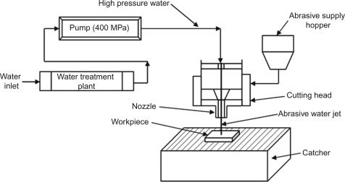 | EBM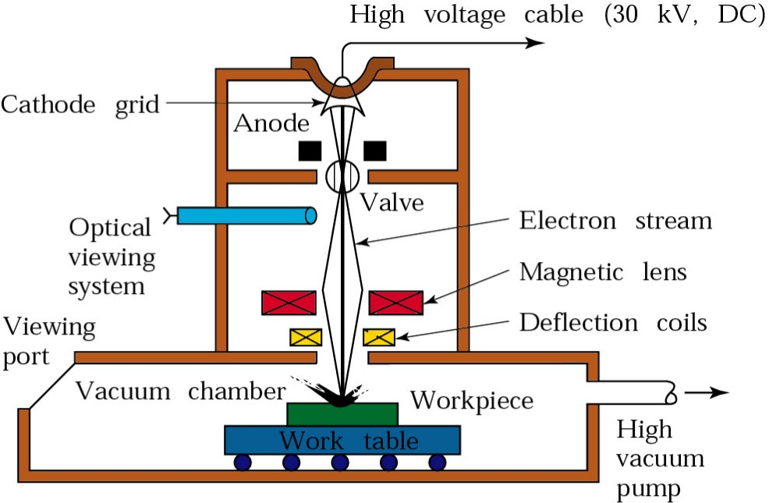

ABRASIVE WATER JET MACHINING |  |  | ABRASIVE JET MACHINING
High pressurise Water is used to carry hard and brittle abrasive particles. |  |  | High pressurise Air is used to carry hard and brittle abrasive particles.
Sr. No. | Features | Description
1 | Mechanism/ Principle of Machining | Brittle Fracture
2 | W M | Rubber, Wood, Ceramics and many soft materials
3 | T M | Convergent Nozzle (Tungsten Carbide) (Abrasives E.g. Al₂O₃, SiC, B₄C, Diamond)
4 | Medium of Machining | Water/ Air (/+Abrasive)
5 | Wear Ration | = Infinite (Tool wear = 0)
6 | Advantages | - Workpiece need not required to be electrical conductor.  - It’s non-hazardous process.  - Hard materials can be machined.  - As there is no heat generated during machining, therefore no hardening of workpiece.  - Can machine thick plates also.
7 | Limitations | - Soft metals can not able to machine i.e. AJM is suitable only for brittle materials as MRR is high for brittle materials.  - Machining accuracy obtained is poor.  - There is always a chance of abrasive particles getting inserted in the work materials hence cleaning needs to be done after machining.  - Used abrasive powder can’t be reuse.
8 | Applications | - This process is best suited for machining brittle and heat sensitive materials like glass, quartz, sapphire, ceramics, etc….  - It’s used for drilling holes, cutting slots, cleaning hard substance deburring, polishing etc…  - It’s used for producing high quality electronic devices.  - It’s used for machining granite and marbles.
LAW OF CONSERVATION OF MOMENTUM: It states that “When two objects collide with each other, the sum of their linear momentum always remains same. i.e. total momentum after collision is always equal to total momentum before collision.”
For Abrasive machining, $m_{a}V_{a}+m_{w}V_{w}=V(m_{a}+m_{w})$
ELECTRON BEAM MACHINING (EBM):
THERMIONIC EMISSION:  The process by which free electrons are emitted from the surface of a metal when external hear energy is supplied is called thermionic emission. | 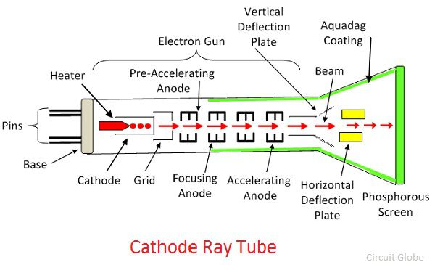
When the high voltage (50-200KV) is applied to Cathode grid it generates the free electron with extremely high velocity in random direction. Anode grid is used to collect this electron and direct in particular direction. Magnetic field has capability to deflect and direct electrons in particular direction. So, the Magnetic lens and Deflection Coils are used for deflecting electrons to workpiece. Due to striking of electrons, it generates high amount of heat flux on very mall area. Hence, melting and vaporising of workpiece melts and vaporising takes place. This process is carried out in vacuum chamber because defective nature of the electron in the atmosphere (or due to different particles in atmosphere).
Sr. No. | Features | Description
1 | Mechanism/ Principle of Machining | Melting and Vaporization
2 | W M | Wide Range of metals and non-metals
3 | T M | Electron Gun, Cathode ray tube or tungsten rod
4 | Medium of Machining | Vacuum
5 | Wear Ration | = Infinite (Tool Wear = 0)
6 | Advantages | - Limited thermal effect on workpiece and extremely small Heat affected zone.  - Workpiece need not required to be electrical conductor.  - Highly reactive materials like Aluminium and Magnesium can be machine because Vacuum is used during machining.  - Since EBM will not have any cutting forces acting on workpiece, thin and fragile workpieces can be machined without any distortion and non-residual stress due to absence of forces.  - It can be used to cut very small holes, of order of 100$μm$.  - WBM is very fast process. Since the beam of electrons moves at a very high velocity, it is possible to complete the drilling process in a short time.  - It’s versatile equipment. The same equipment can be used for annealing and/ or welding since it will not use any tool.
7 | Limitations | - Unlike LBM, this process requires vacuum, so workpiece size is limited to the size of vacuum chamber.  - EBM equipment is expensive and can only justified for the type of part dimensions and accuracy requirements.  - Low MRR.  - Hole Shape is affected by the depth of workpiece. Because of the divergence nature of the beam away from the focal point, the hole will have an hourglass shape.
8 | Applications | - EBM is mainly used for micromachining operations such as drilling, perforation, slotting, engraving etc. on thin materials.  - EBM is suited particularly for materials with high melting points and low thermal conductivity.  - To drill extremely small holes of diameter 0.03 mm in turbine blades for transpiration cooling, holes in mixer plates, combustion chamber rings.
ELECTRON BEAM WELDING (EBW):
- EBW is a welding process utilizing a heat generated by beam of high energy electrons.
- These electrons strike the workpiece and their kinetic energy converts into thermal energy heating the metal so that the edges of workpiece are fused and joined together forming a weld after solidification.
Power required = Energy Consumed/ Unit time = P = V I
LASER BEAM MACHINING (LBM):
- A high voltage electric supply makes the tube flash on and off.
- Every time the tube flashes it “Pumps” energy into the rube crystal. The flashes it makes inject energy into the crystal in the form of photons.
- Atoms in the ruby crystal soak up this energy in a process is called absorption. Atom absorb energy when their electrons jump to higher energy level. After few milli seconds, the electrons return to their original energy level by giving off a photon of light. This is called spontaneous emission.
- The photons that atoms give off zoom up and zoom inside the ruby crystal, travelling the speed of light.
- Every so often, one of these photons stimulates an already excited atom. When this happens, the excited atom gives off a photon and we get our original photon back as well. This is called stimulated emission. Now one photon of light has produced two, so the light has been amplified (Increased in strength). In other words, “Light amplification” (An increase in the amount of light) has been used by “Stimulated emission of radiation” (Hence, the name LASER, because that’s exactly how a laser works!)
- A mirror at one end of the lase tube keeps the photons bouncing back and forth inside the crystal.
- A partial mirror at the other end of the tube bounces some photons back into the crystal but let’s some escape.
- The escaping photons form a very concentrated beam of powerful laser light.
Sr. No. | Features | Description
1 | Mechanism/ Principle of Machining | Melting and vaporization.
2 | W M | Plastics, Glasses, Semiconductors, Ceramics and metals. (Less Reflective)
3 | T M | Ruby Laser, Nd:YAG Laser, CO2 Laser
4 | Medium of Machining | Atmospheric Air
5 | Wear Ration | = Infinite (Tool Wear = 0)
6 | Advantages | - Ability to cut almost all material including fragile materials.  - No limit to cutting paths as the laser point can move in any path.  - No direct contact between tool and workpiece, thus no need of workpiece holding system.  - Flexibility exists in precision cutting of simple or complex parts.  - There is no tooling cost or associated wear cost.  - Laser produces high Quality cuts without extra finishing requirement.
7 | Limitations | - Laser process involves high capital investment and high operating cost.  - Laser Holes are tapered to some extent (Approx. 1% of drill depth)  - It can’t drill blind holes to precise depth.  - Heat of lasers may change mechanical properties of metallic materials.  - Long processing time in large holes due to trepanning acting.  - Reflected laser lights can lead to safety hazards issue.  - Assist or cover glasses are required for safety purpose.
8 | Applications | - Heat Treatment, Welding, Machining, material decomposition lithography, surgery, photo-polymerization, $μ$-Sterio-Lithography, Laser-enhanced jet plating and etching.  - Used for Ablation or cutting of plastics, glasses, ceramics, semiconductors and metals.  - Zig-Zag Holes can be produced.
EBM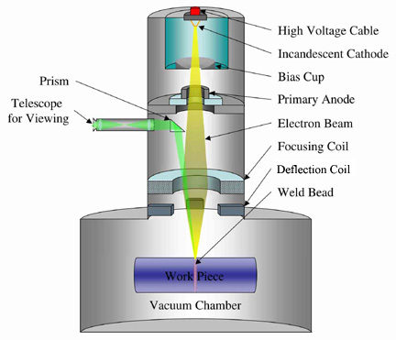 |  |  | LBM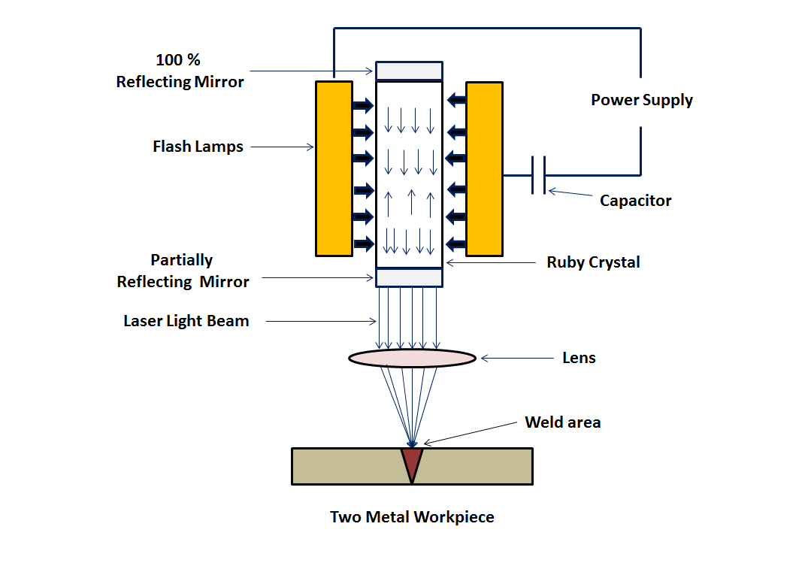
LIGHT AMPLIFICATION BY STIMULATED EMISSION OF RADIATION
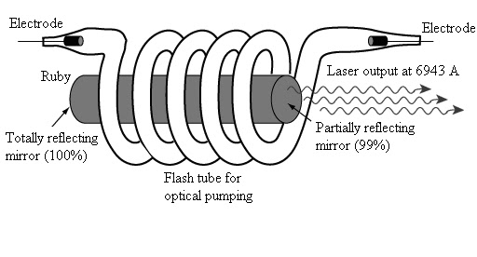 |  |  | 